AI ASSISTED CODING
LAB-9.1
AKSHARA JYOTHI.V
2303A51786Batch-12
Problem 1:
Consider the following Python function: def find_max(numbers): return max(numbers)
Task:
• Write documentation for the function in all three formats:
- Docstring
- Inline comments
- Google-style documentation
- Critically compare the three approaches. Discuss the advantages, disadvantages, and suitable use cases of each
style.
- Recommend which documentation style is most effective for a mathematical utilities library and justify your answer.
- Docstring
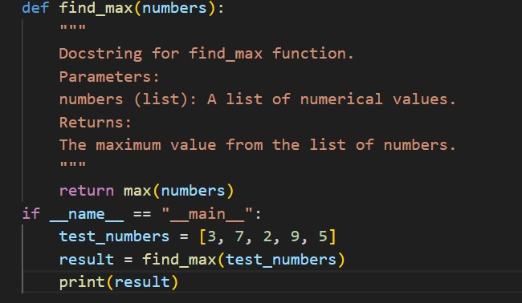
- Inline comments
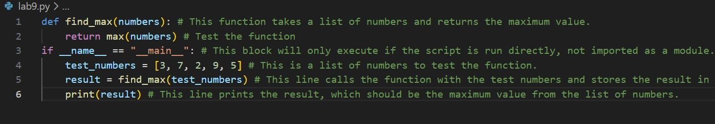

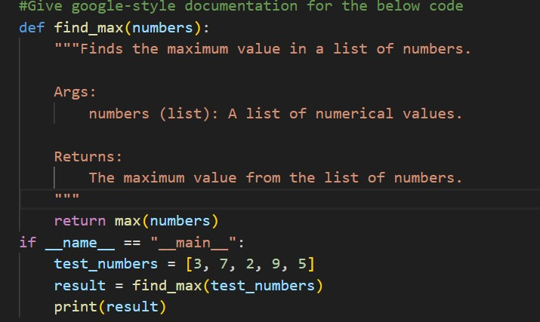
(
c) Google
-
style documentation

Problem 2:
Consider the following Python function: def login(user, password, credentials): return credentials.get(user) == password Task:
- Write documentation in all three formats.
- Critically compare the approaches.
- Recommend which style would be most helpful for new developers onboarding a project, and justify your choice.
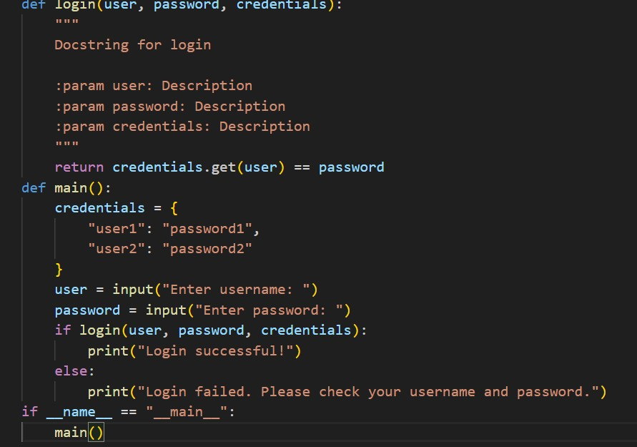
(
a) Docstring

(
b) Inline comments

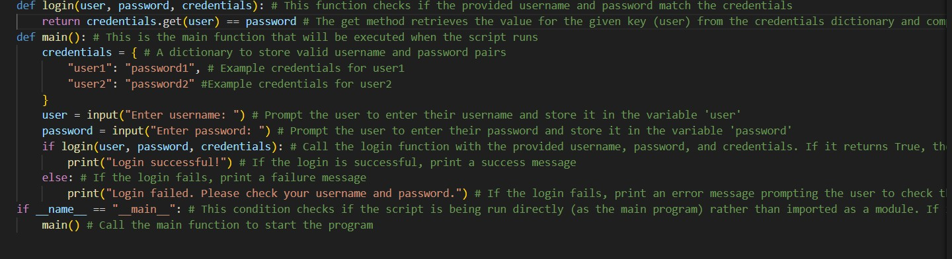

(c) Google-style documentation
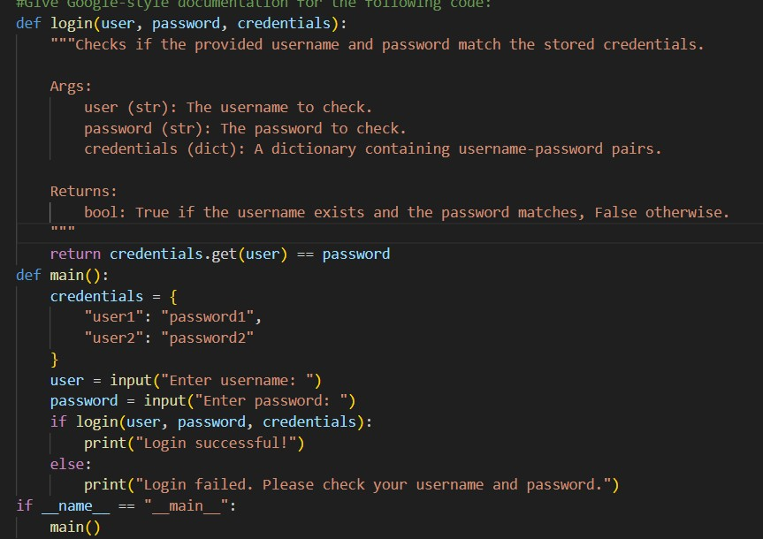
Problem 3: Calculator (Automatic Documentation Generation)
Task: Design a Python module named calculator.py and demonstrate automatic documentation generation.
Instructions:
1. Create a Python module calculator.py that includes the following functions, each written with appropriate docstrings:
- add(a, b) – returns the sum of two numbers o subtract(a, b) – returns the difference of two numbers o multiply(a, b) – returns the product of two numbers
- divide(a, b) – returns the quotient of two numbers
- Display the module documentation in the terminal using Python’s documentation tools.
- Generate and export the module documentation in HTML format using the pydoc utility, and open the generated HTML file in a web browser to verify the output.
Prompt:
#Give python code for a calculator that has functions of addition, subtraction, multiplication and division
Docstring
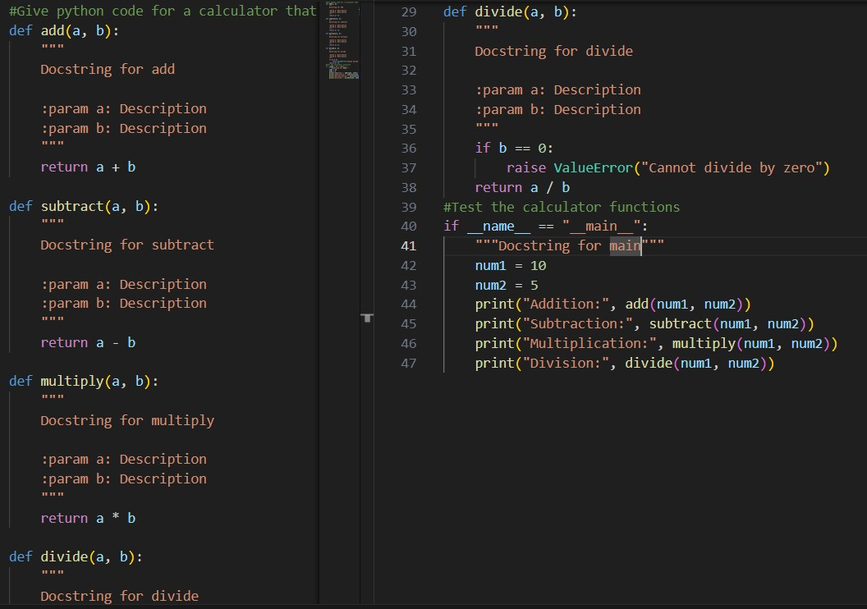
Using pydoc
1) python -m pydoc filename
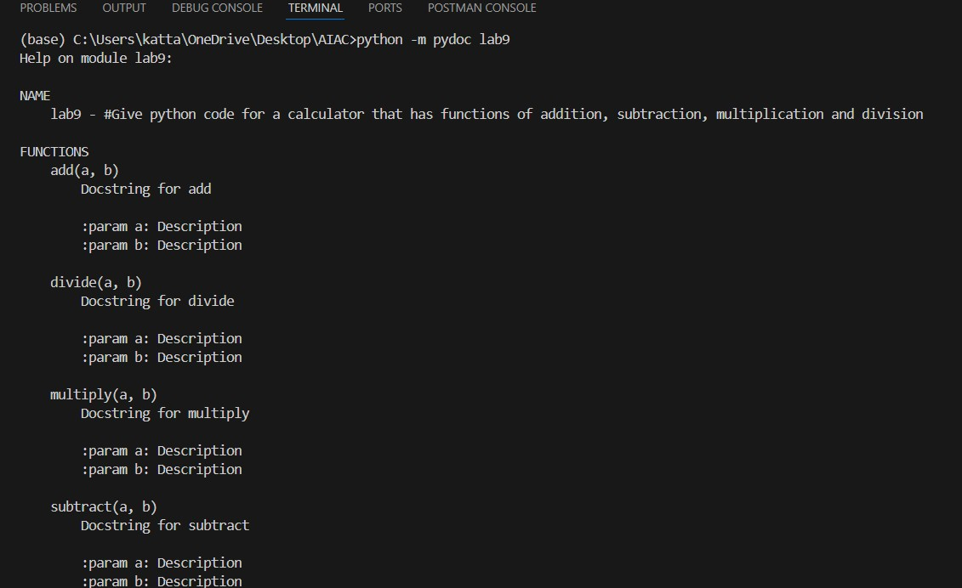

2)
python
-
m pydoc
-
w filename

3) python -m pydoc -p 8080
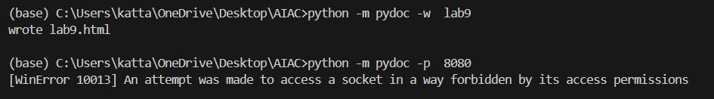

Problem 4: Conversion Utilities Module

Task:
1. Write a module named conversion.py with functions:
o decimal_to_binary(n) o binary_to_decimal(b) o decimal_to_hexadecimal(n)
- Use Copilot for auto-generating docstrings.
- Generate documentation in the terminal.
- Export the documentation in HTML format and open it in a browser.
Given Code:
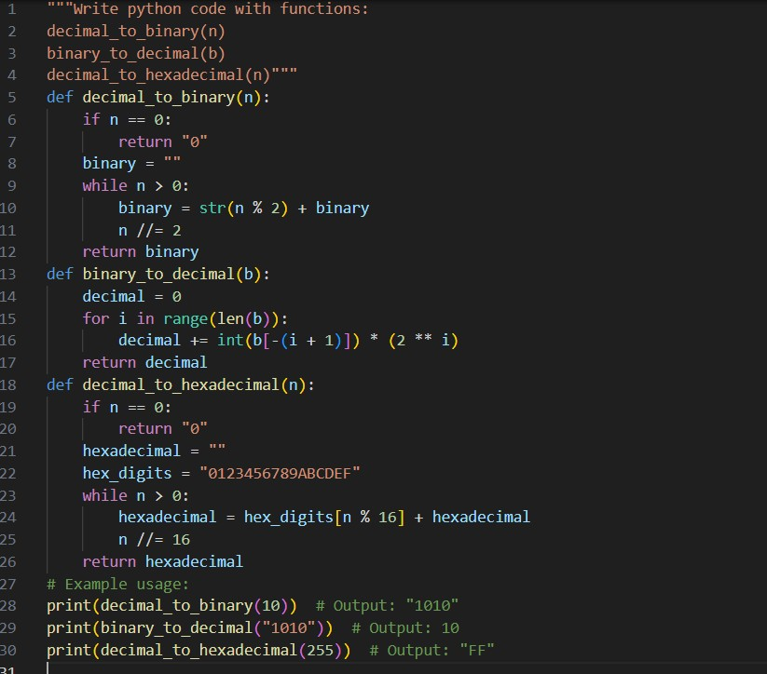
Docstring:
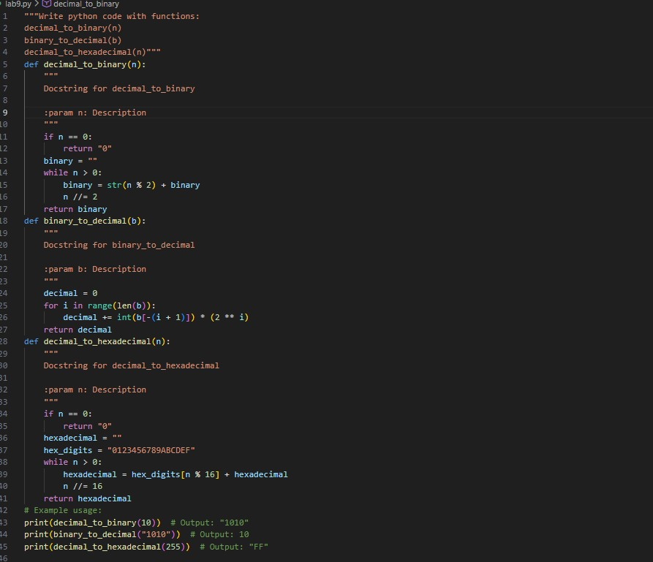
Using pydoc
1) python -m pydoc filename
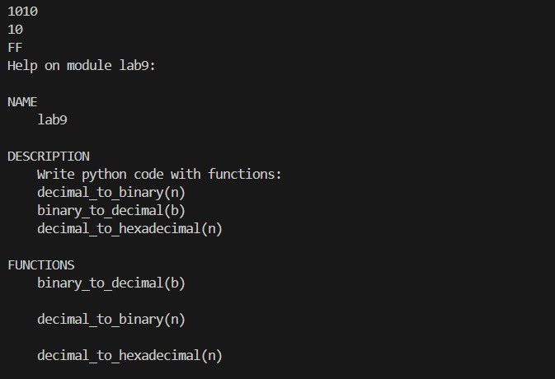
2)python -m pydoc -w filename
3)python -m pydoc -p 8080
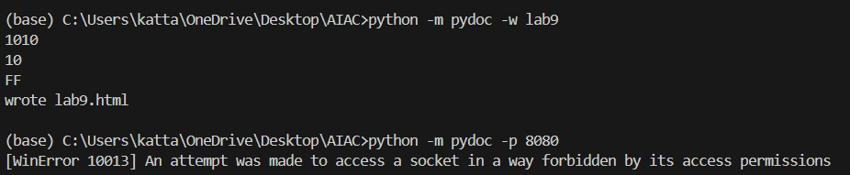

Problem 5
–

Course Management Module

Task:
- Create a module course.py with functions: o add_course(course_id, name, credits) o remove_course(course_id) o get_course(course_id)
- Add docstrings with Copilot.
- Generate documentation in the terminal.
- Export the documentation in HTML format and open it in a browser
Given Code:
Docstrings:
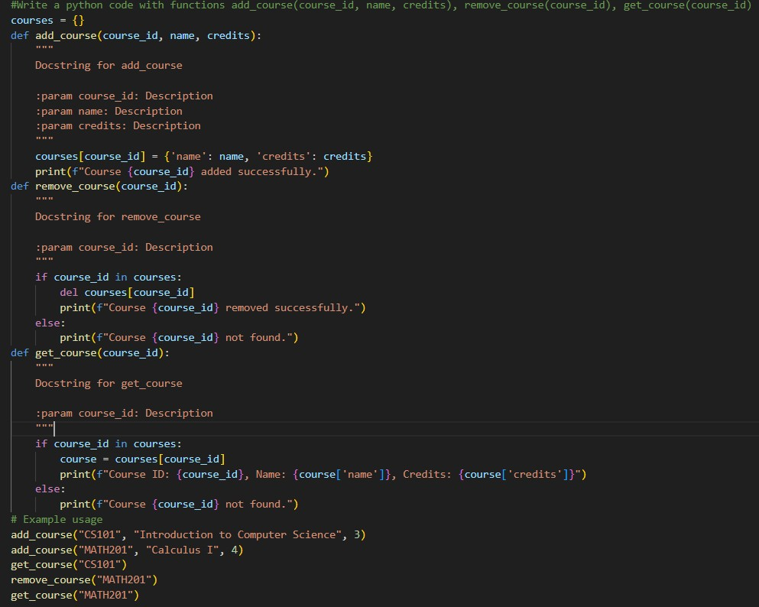

Using pydoc

1) python -m pydoc filename
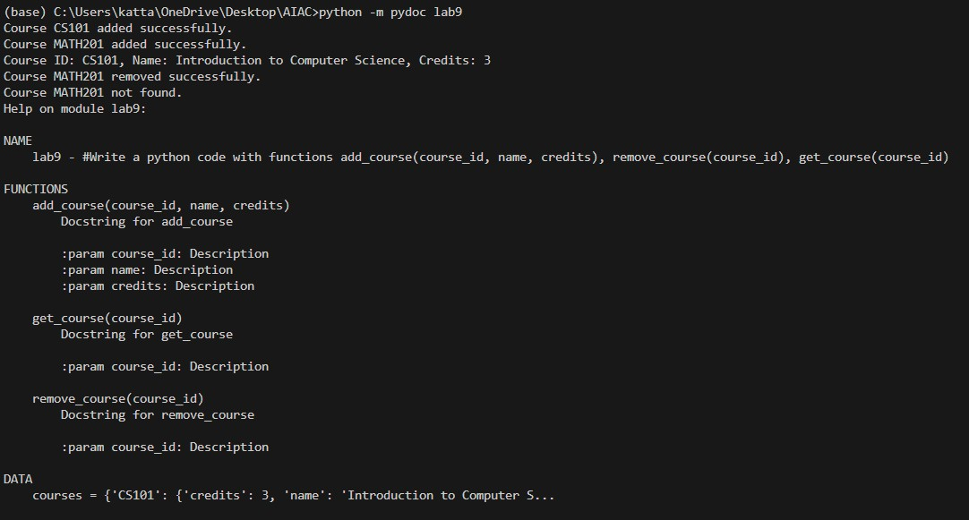

2)python -m pydoc -w filename
3)python -m pydoc -p 8080
